Neo Modern

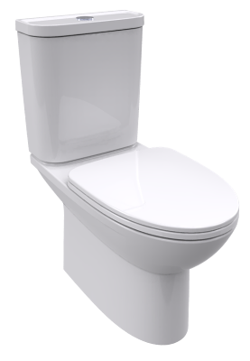vdalve & flexible hose CCAS2074-2200400C0
Close Coupled Toilet
TF-2630
SPECIFICATIONS
- Flushing Type: Dual Flush 3 / 4.2 L
- Push Button: Top push
- Outlet Type: P Trap & S Trap with Plastic Connector
- Bowl Shape: Elongated
- Rough in: S-trap 305 mm., P-trap 190 mm
- Overall Dimensions: W376*L710*H792 mm.
- Height to rim: 390 mm.
- Material: Vitreous China
FEATURES
- Dual Flush Wash Down
- Water Saving
- Concealed Trapway
- Slow Closing Seat & Cover

COLOR AVAILABILITY
- White only(0)

INCLUDED COMPONENTS
- Slow Closing Seat & Cover
- Tank Fitting Set
- Connector
- L-Shape Floor Fixing
- Stop Valve
- Installation manual

SHIPPING WEIGHT
- Net Weight: 42.0 KGs.
- Gross Weight:

STANDARD CRITERIA
- TIS-792:2554_2011
- PNS-993-2010
- MS 1522-2011
- SS 378-1996
- GB 6952-2005

DIMENSIONAL DRAWING

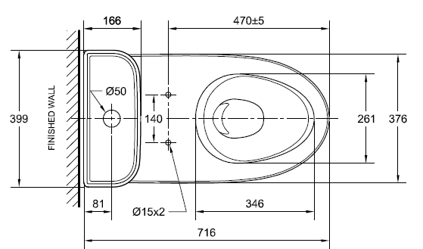

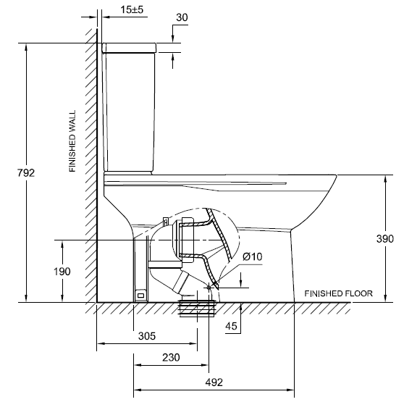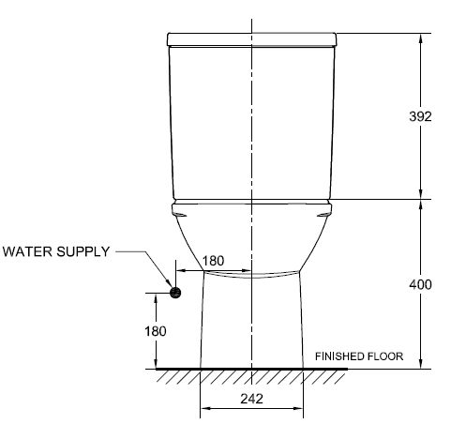

This document is the property of American Standard. It can neither be reproduced, nor communicated, without authorization.
American Standard reserves the right to change dimensions and specifications without notice; we assume no liability for the use of obsolete dimensions.

