Kastello

Vessel
CCASF525
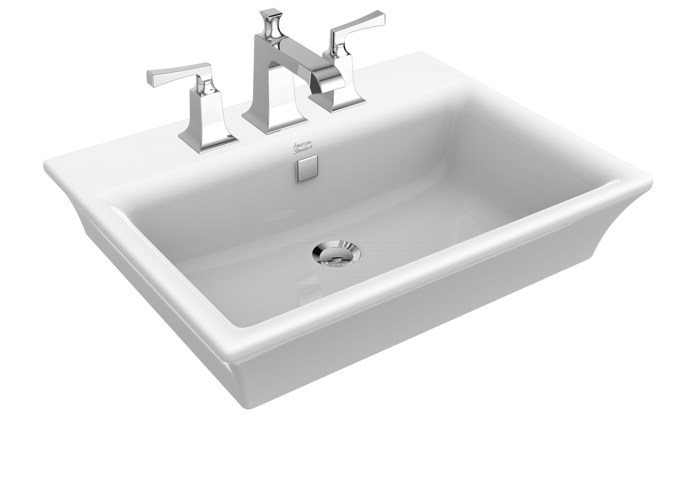
FEATURES
- Classic design
- With overflow

SPECIFICATIONS

Faucet Drillings: single, 8”
Overall Dimensions: L600xW460xH166mm
Material: Fine Fire Clay

SHIPPING WEIGHT
Net Weight: 17 KG
DIMENSIONAL DRAWING

OPTIONS

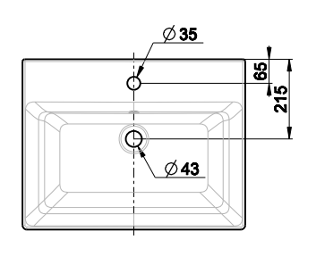
CCASF525-1010410C0 Single hole
CCASF525-1080410C0 8” hole

STANDARDS CRITERIA
- GB6952-2015
- TIS792-2011

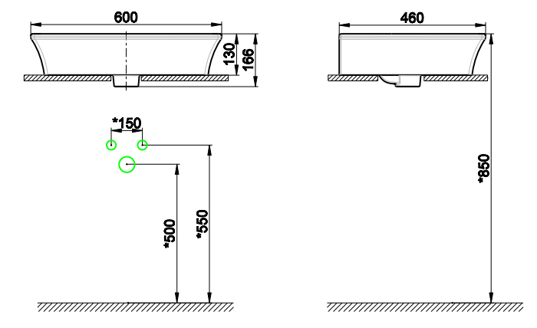

This document is the property of American Standard. It can neither be reproduced, nor communicated, without authorization.
American Standard reserves the right to change dimensions and specifications without notice; we assume no liability for the use of obsolete dimensions.

