New Codie II (Thailand)
One-Piece Toilet
TF2024 (305mm RI)

STANDARDS CRITERIA
- TIS-792:2001
- GB 6952-2005
- PNS 156:2010
- MS 1522:2007
- SS 378-1996
- ASME-A112.19.2-2008
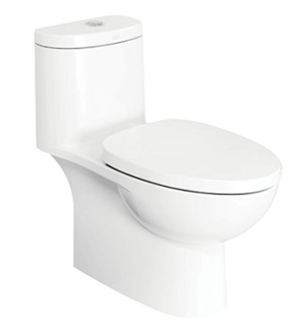
FEATURES
- Types of Flushing: Washdown
- Design: Modern design with wider size for more comfortable seating
- Trapway: Concealed trapway
- Seat: Comfort Seat and Slow Close
- Water Saving: 3/4.5L water saving

SPECIFICATIONS
- Litres Per Flush: 3/4.5 lpf
- P/S-Trap/Bowl Shape: S trap, elongated
- Roughing in: 305mm floor discharge
- Overall Dimensions (LxBxH):
L709xW350xH712mm
- Height to Rim: 400mm
- Material: Vitreous China

COLOR AVAILABILITY
- White only(0)
INCLUDED COMPONENTS
- Slow closing seat & cover
- Dual tank fitting set
- S-trap connector
- L-shape floor fixing set
- Stop valve
- Installation manual
STANDARDS CRITERIA
- TIS-792:2001
- GB 6952-2005
- PNS 156:2010
- MS 1522:2007
- SS 378-1996
- ASME-A112.19.2-2008

DIMENSIONAL DRAWING
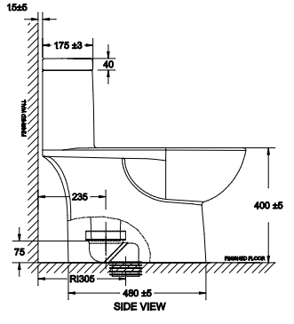
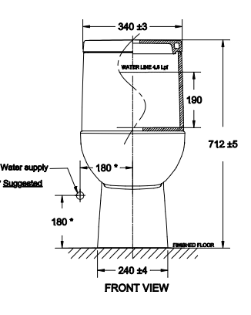

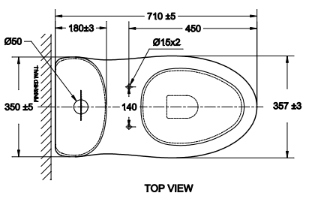

This document is the property of American Standard. It can neither be reproduced, nor communicated, without authorization.
American Standard reserves the right to change dimensions and specifications without notice; we assume no liability for the use of obsolete dimensions.
STANDARDS CRITERIA
- TIS-792:2001
- GB 6952-2005
- PNS 156:2010
- MS 1522:2007
- SS 378-1996
- ASME-A112.19.2-2008

