Acacia SupaSleek

BTW Toilet
CL3229

FEATURES

Double Vortex Wash Down

Aqua Cermaic&Comfort Clean

Water Saving
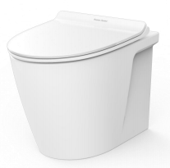
Rimless
CrystaSleek Seat & Cover

SPECIFICATIONS

Flushing Type: Dual Flush 3/4.5 Litres per flush
Tank Fitting: Concealed cistern
Outlet type: S-trap & P-trap
Bowl shape: Elongated
Overall Dimensions: W376xL555xH390mm
Height to rim: 390 mm.
Material: Vitreous China

COLOR AVAILABILITY

White (WT)

INCLUDED COMPONENTS

L-shape floor fixing set 80 mm
Installation manual

SHIPPING WEIGHT
Net weight: 31 KGs
Gross weight: 34.4 KGs

STANDARDS CRITERIA
TIS-792:2001

DIMENSIONAL DRAWING

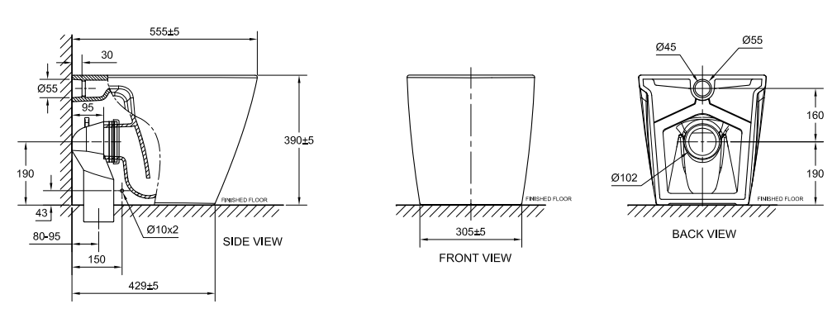
S-trap

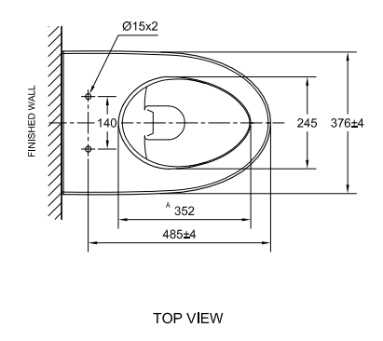

P-trap

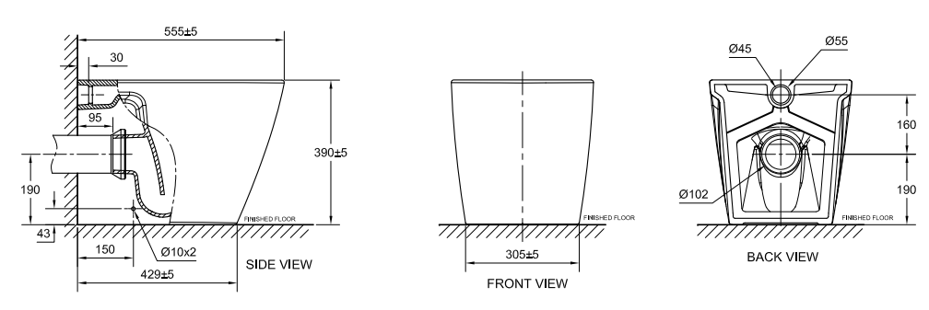

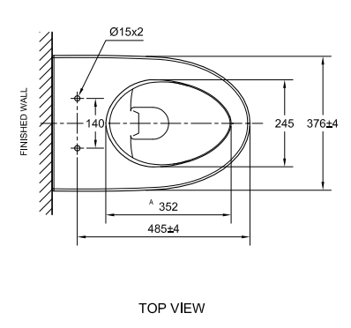

This document is the property of American Standard. It can neither be reproduced, nor communicated, without authorization.
American Standard reserves the right to change dimensions and specifications without notice; we assume no liability for the use of obsolete dimensions.

