Acacia SupaSleek

CCBTW Toilet
CL3317/CL4317

FEATURES

Double Vortex Wash Down

Aqua Ceramic

Water Saving
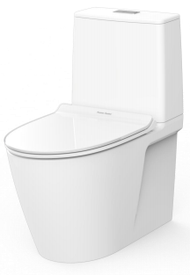
Rimless
Comfort Clean
Crystal Sleek Seat & Cover

SPECIFICATIONS

Flushing Type: Dual Flush 3/4.5 Litres per flush
Push Button: Top push
Roughing in : S-trap 140-245mm
Bowl shape: Elongated
Overall Dimensions: W376xL680xH780mm.
Height to rim: 390 mm.
Material: Vitreous China

COLOR AVAILABILITY

White (WT)

INCLUDED COMPONENTS

L-shape floor fixing set 80 mm
Installation manual

SHIPPING WEIGHT
Net weight: 31 KGs
Gross weight: 34.4 KGs

STANDARDS CRITERIA
TIS-792:2001

DIMENSIONAL DRAWING

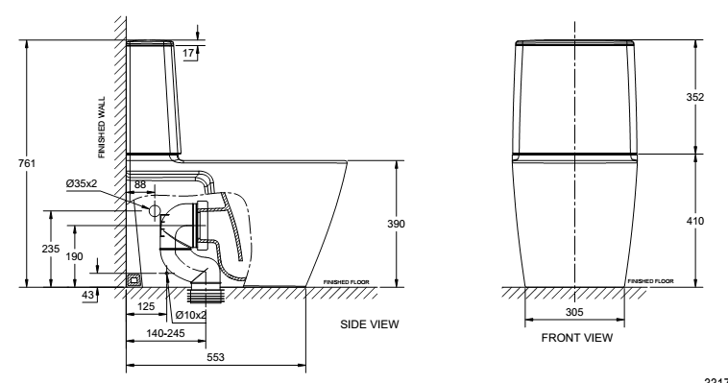

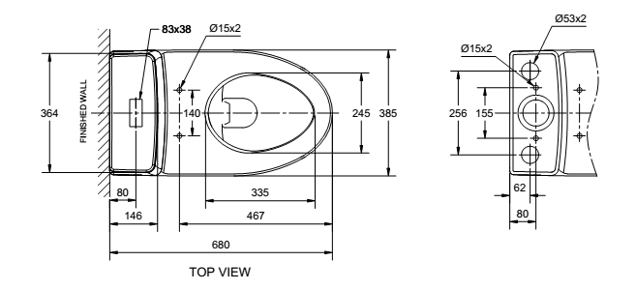

This document is the property of American Standard. It can neither be reproduced, nor communicated, without authorization.
American Standard reserves the right to change dimensions and specifications without notice; we assume no liability for the use of obsolete dimensions.

