

**Acacia Evolution**



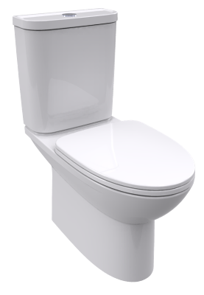vdalve & flexible hose CCAS2074-2200400C0

**SPECIFICATIONS**

* Flushing Type: Dual Flush 3 / 4.5 L
* Tank Fitting: Concealed cistern
* Outlet Type: P-trap
* Bowl Shape: Elongated Bowl
* Overall Dimensions: W376*L555*H360 mm.
* Material: Vitreous China

Wall Hung Bowl

TF-3119



**FEATURES**

* Double Vortex Wash Down
* Proguard Technology
* Water Saving
* Rimless
* Slow Closing Seat & Cover

**COLOR AVAILABILITY**

* White only(0)

**INCLUDED COMPONENTS**

* Fixation for wall hung
* Installation Manual

**SHIPPING WEIGHT**

* Net Weight: 23.21 KGs
* Gross Weight: 25 KGs.

**STANDARD CRITERIA**

* TIS-792:2554_2011
* PNS-993-2010
* ASME-A112.19.2-2008

**DIMENSIONAL DRAWING**

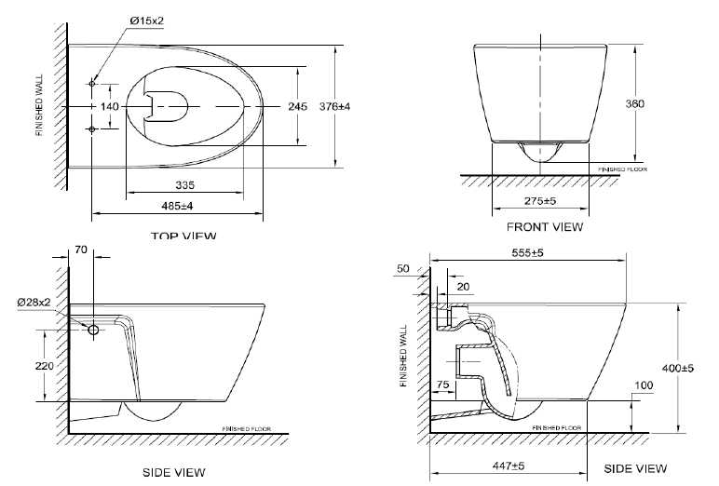

This document is the property of American Standard. It can neither be reproduced, nor communicated, without authorization.

American Standard reserves the right to change dimensions and specifications without notice; we assume no liability for the use of obsolete dimensions.