Concept Nuovo

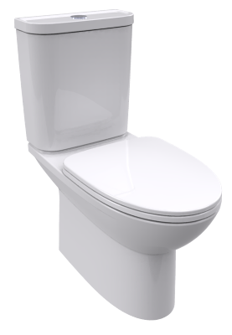vdalve & flexible hose CCAS2074-2200400C0
Wall Hung Bowl
TF-3105
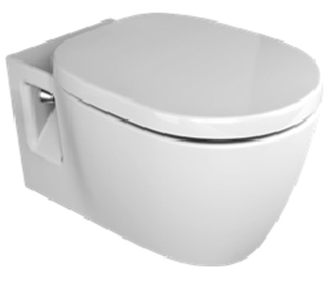
SPECIFICATIONS
- Flushing Type: Dual Flush 3 / 4.5 L
- Tank Fitting: Concealed cistern
- Outlet Type: P-trap
- Bowl Shape: Round Bowl
- Overall Dimensions: W365*L560*H352 mm.
- Material: Vitreous China
FEATURES
- Dual Flush Wash Down
- Water Saving
- Slow Closing Seat & Cover

COLOR AVAILABILITY
- White only(0)

INCLUDED COMPONENTS
- Installation Manual

SHIPPING WEIGHT
- Net Weight: 28.25 KGs
- Gross Weight: 31 KGs.

STANDARD CRITERIA
- TIS-792:2554_2011
- PNS-993-2010
- ASME-A112.19.2-2008

DIMENSIONAL DRAWING

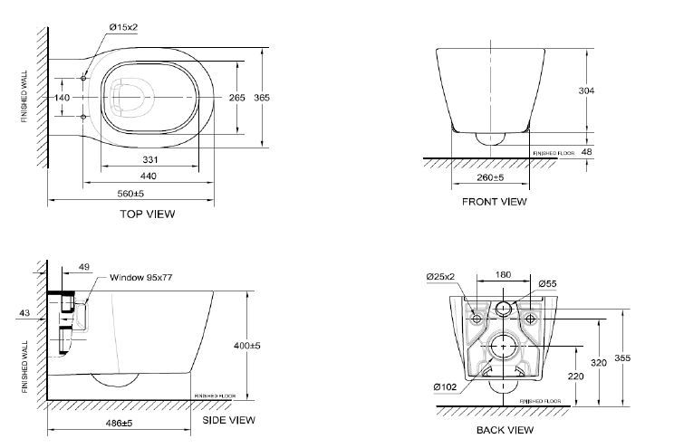

This document is the property of American Standard. It can neither be reproduced, nor communicated, without authorization.
American Standard reserves the right to change dimensions and specifications without notice; we assume no liability for the use of obsolete dimensions.

