Neo Modern

One Piece Toilet
TF-2531
FEATURES
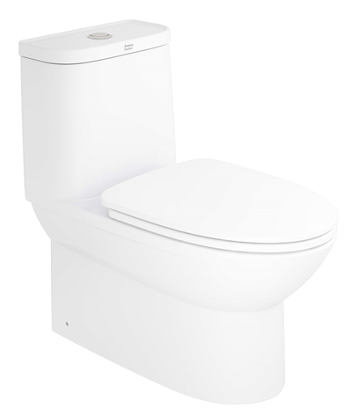
- Double Vortex Washdown
- Water Saving
- Slow Closing Seat & Cover, Comfort Curve Seat
- Comfort Clean Glaze

SPECIFICATIONS

Flushing Type: Dual Flush 3/4.2 Litres per flush
Push Button: Top push
Roughing in : S-trap 305mm/P-trap 190mm
Bowl shape: Elongate
Overall Dimensions: W374xL740xH730mm
Height to rim: 390 mm
Material: Vitreous China

SHIPPING WEIGHT
DIMENSIONAL DRAWING
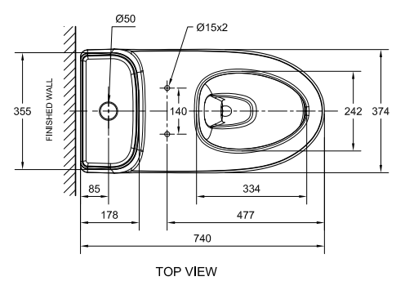
Net Weight: 48 KG
Gross Weight: 59 KG

INCLUDED COMPONENTS

L-shape floor fixing set 80 mm
Installation manual

STANDARDS CRITERIA
TIS 792-2001
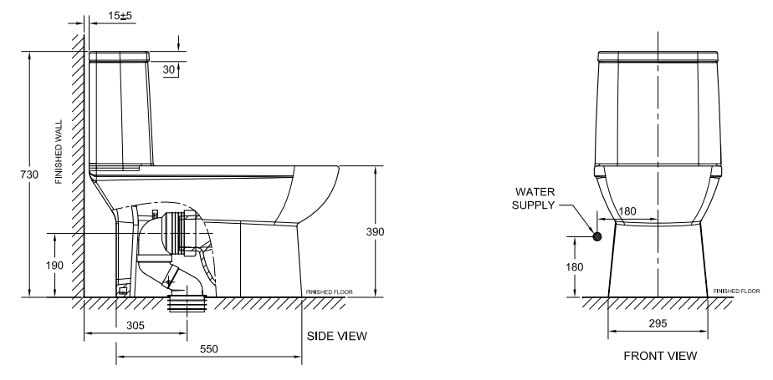
EN 997-2012
MS 1522-2011
SNI 03-0797-2006
PNS156-2010

This document is the property of American Standard. It can neither be reproduced, nor communicated, without authorization.
American Standard reserves the right to change dimensions and specifications without notice; we assume no liability for the use of obsolete dimensions.

