Acacia SupaSleek

One-Piece Toilet
CL20075-6DACTCBT
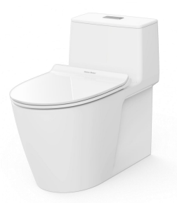

FEATURES

Double Vortex Wash Down

Aqua Ceramic and Comfort Clean
Water Saving
Rimless
Easy to Clean
CrystaSleek Seat & Cover

SPECIFICATIONS

Flushing Type: Dual Flush 2.6/4 Litres per flush
Push Button: Top push
Outlet type: P-trap & S-trap with Plastic Connector
Bowl shape: Elongated
Roughing in: S-trap 305 mm., P-trap 190 mm
Overall Dimensions: W385xL747xH634 mm
Height to rim: 390 mm.
Material: Vitreous China

COLOR AVAILABILITY

White (WT)

INCLUDED COMPONENTS

Slow closing seat & cover
Dual tank fitting set
S-trap connector
L-shape floor fixing set
Plastic side cover
Stop valve
Installation manual

SHIPPING WEIGHT
Net weight: 49.2 KGs
Gross weight: 58.7 KGs

STANDARDS CRITERIA
TIS-792:2001
GB 6952-2005
PNS 156:2010
MS 1522:2007
SS 378-1996
ASME-A112.19.2-2008

DIMENSIONAL DRAWING

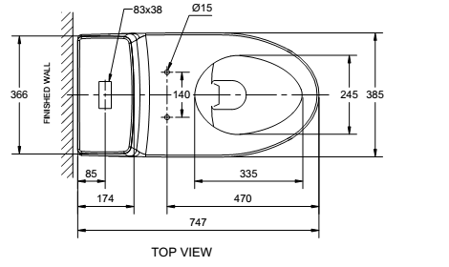

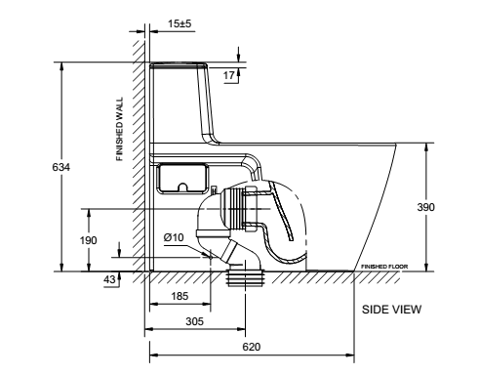
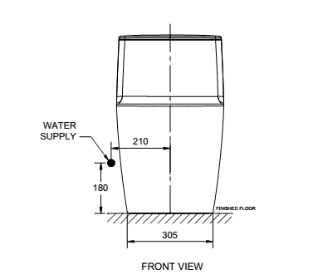

This document is the property of American Standard. It can neither be reproduced, nor communicated, without authorization.
American Standard reserves the right to change dimensions and specifications without notice; we assume no liability for the use of obsolete dimensions.

