

**Acacia Evolution**



Semi Counter Lavatory

TF-0519

**FEATURES**

\\ranthfs001\LIXILasean\4_Product_Pictures\1_VC\VC\HiRes\WashBasins\Acacia Evolution\acaciaE semi counter (TF-0519).tifProguard

Technology

Easy to Clean

Overflow hole on back position

**SPECIFICATIONS**

Faucet Drillings: Single / T4" / T8"

Basin Dimensions: W460xL500xH180 mm.

Material: Vitreous China

**COLOR AVAILABILITY**

White (WT)

**INCLUDED COMPONENTS**

Overflow plug

Brackets & Adjustable Hook

Installation Template

**SHIPPING WEIGHT**

Net Weight: 15.7 KGs

Gross Weight: 17.7 KGs

**DIMENSIONAL DRAWING**

**STANDARDS CRITERIA**

TIS Standard

EN Standard

ASME Standards

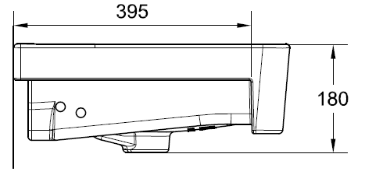



This document is the property of American Standard. It can neither be reproduced, nor communicated, without authorization.

American Standard reserves the right to change dimensions and specifications without notice, we assume no liability for the use of obsolete dimensions.