Concept Nuovo Round
Flush Plate
CLCN60ZZ
Application Purpose
- For dual flush
- For front actuation
- For stop-and-go flush

Characteristics
- Mechanical faceplate
- Dual flush with CLCN51ZZ, CLCN52ZZ, CLCN53ZZ, CLCN54ZZ, CLCN55ZZ
- Tool-free mounting and maintenance work on concealed cistern

Product Details
- Actuation force ＜20N
- Product material: Plastic, Chrome（-cp）

AWARDS WON
- N/A

SHIPPING WEIGHT
- Product net weight: 0.29 kg/set
- Product gross weight: 0.42 kg/set

STANDARDS CRITERIA
- GB26730

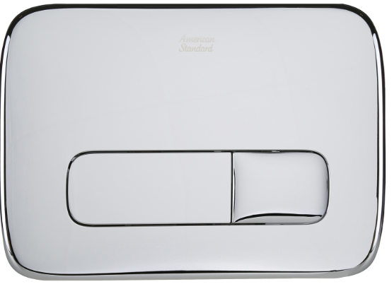

DIMENSIONAL DRAWING

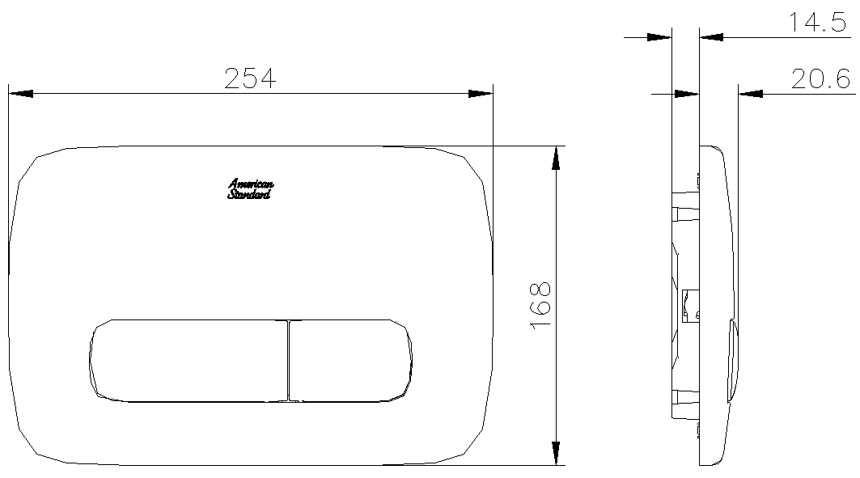

This document is the property of American Standard. It can neither be reproduced, nor communicated, without authorization.
American Standard reserves the right to change dimensions and specifications without notice, we assume no liability for the use of obsolete dimensions.

